Worksheet 10.1

Investigating neurons
Student: Class:
The nervous system is made up of billions and billions of neurons. A neuron is an individual nerve cell that transmits information around the body, combining it with information from other sources.
Neurons have specialised functions. Some neurons specialise in transmitting information from the sense organs and muscles to the CNS. Other neurons specialise in sending information to the organs, muscles or glands from the CNS. Some neurons carry information between neurons.
The number of neurons in the human body is not known. However, estimates of the number of neurons in the human brain alone range from 10 billion to about 100 billion neurons. The entire nervous system that extends throughout the body is comprised of neurons that connect with many other neurons to enable the continuous communication of information around the body. Unlike skin cells, for example, the body does not replace neurons if they die. However, the function of a neuron, if damaged, is often taken over by another neuron.
Not all neurons look the same. They vary in shape and size depending on where they are located in the body and on their specific function. However, most neurons have some features in common.
The diagrams on this worksheet show the different types of neurons in the human body. They also shows the various parts of each neuron.

Structure of the neuron
Soma: The soma is the large section located centrally in the neuron. The soma, or cell body, is the structure that determines whether the neuron will be activated and thus transmit (send) messages to other neurons.
Within the soma is the nucleus of the neuron. The nucleus contains the biochemical information that provides the energy to keep the neuron functioning. The soma has a number of extensions that branch from it. There are two main types of extensions — dendrites and axons. Some neurons have thousands of dendrites that extend from the soma, but most neurons have only one axon.
Dendrite: A dendrite is a short, thin, widely branching nerve fibre that is specialised to detect and receive neural information. Like an antenna, dendrites receive incoming information from other neurons and transmit the information to the soma.
Axon: An axon is a single, tubelike, fluid-filled extension that transmits messages from the soma to other cells in the body including other neurons, muscles, organs and glands. Most neurons have only one axon.
Axons vary in length, for example, some axons extend over a metre from your spine to your big toe, others are as small as the width of a single hair.
At the end of each axon are branches called axon terminals. Each axon terminal has a small knob-like swelling at the tip of it called a synaptic knob or terminal button.
The synaptic knob is a small structure like a sack that stores chemicals called neurotransmitters that assist in the transmission of neural information from one neuron to another. Axon terminals are located physically close to dendrites of other neurons, enabling information to pass easily between neurons as messages are transmitted to and from the CNS.

The role of neurons
There are three main types of neurons, each of which has a different role in the nervous system. The three types of neurons are called sensory neurons, motor neurons and interneurons.
Sensory neurons and motor neurons are found primarily in the peripheral nervous system, whereas interneurons are primarily found in the CNS.

Worksheet 10.1

Page 2

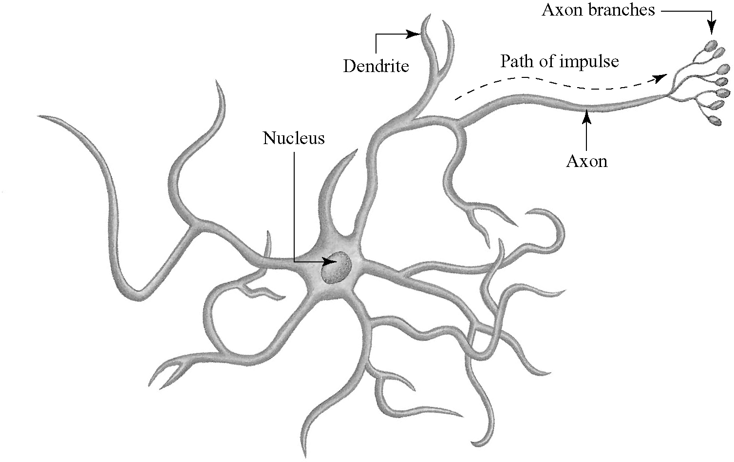
Sensory neurons are specialised cells that receive information from both the external environment and from within the body and transmit this information to the CNS. Information is received from the external environment via the sense organs and internally, within the body from the muscles, organs and glands. Some sensory neurons transmit information directly to the spinal cord, whereas other sensory neurons transmit information to the brain via the spinal cord.
Sensory neurons
You are able to read the words on this page because sensory neurons are transmitting information from your eyes to your brain.
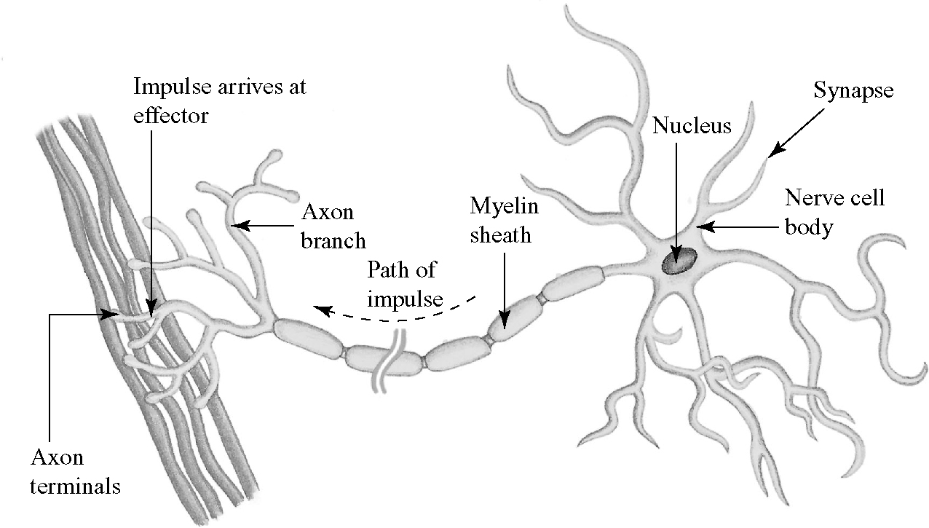
Motor neurons transmit messages from the CNS to the muscles, glands and organs. They enable muscles to move, cause glands to secrete chemicals and activate internal organs. You are able to walk because motor neurons send messages from the CNS to enable the muscles in your legs and feet to move.
Motor neurons

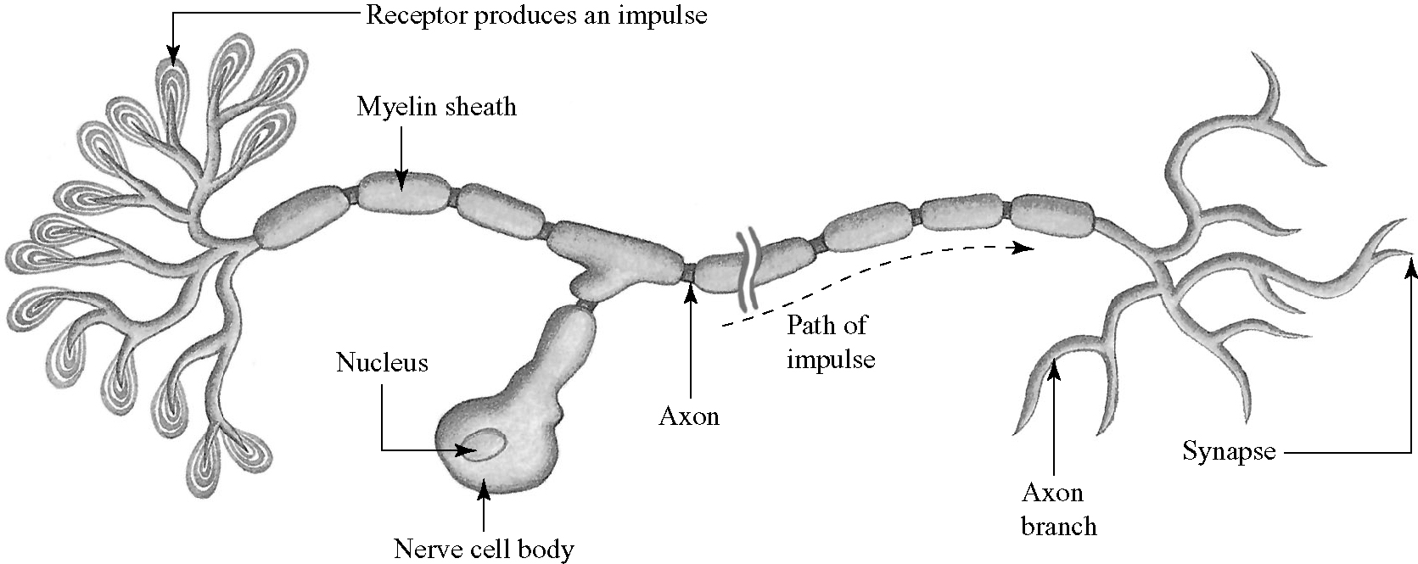
Interneurons exist
only within the CNS. They have a specialised role of carrying and integrating messages between sensory and motor neurons. Interneurons provide neural links between sensory and motor neurons.
Interneurons

Investigating the structure of neurons
Use wire, plasticine, match sticks, beads and pipecleaners to make a model of sensory, motor and interneurons; label each part of the neurons.

